4.5 Triple Integrals Worksheet

- The integral of the function over a region R is computed by .
- Mark the box below of the picture of the region R.

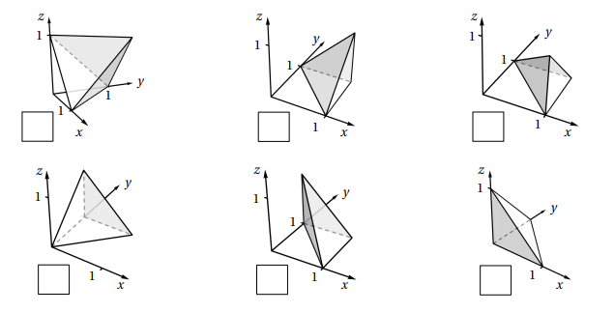

- Evaluate the iterated integral from part (a).

- Re-express this iterated integral with differentials in the order of dzdydx.

- Re-express this iterated integral with differentials in the order of dydzdx.

- The integral of the function over a region R is computed by .

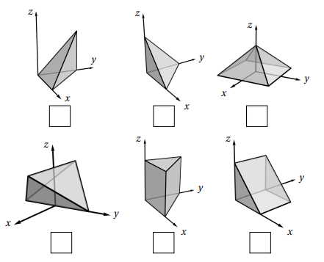
- Mark the box below of the picture of the region R.

- Evaluate the iterated integral from part (a).

- Re-express this iterated integral with differentials in the order of dzdxdy.

- Re-express this iterated integral with differentials in the order of dxdydz.

- The integral of the function over a region R is computed by .


- Mark the box below of the picture of the region R.

- Evaluate the iterated integral from part (a).

- Explain why this iterated integral cannot be re-expressed as a single integral with differentials in the order of dxdzdy. Then, re-express this iterated integral as the sum of two integrals with differentials in the order of dxdzdy.

- Re-express this iterated integral as the sum of two iterated integrals with differentials in the order of dzdydx.

- Consider the solid determine by the region
- Draw a picture of the solid communicated by this integral.

- Set up an iterated integral which represents the volume of this region.

- Rewrite this iterated integral so that the differentials are in the order: .

- Suppose is a continuous function. Consider the iterated integral: .

- Draw a picture of the solid communicated by this integral.

- Rewrite this iterated integral so that the differentials are in the order: .

- If E represents the region of integration, then determine the projection of E onto the xz-plane.

- If E represents the region of integration, then determine the projection of E onto the yz-plane.

- Suppose is a continuous function. Consider the iterated integral: .
- Draw a picture of the solid communicated by this integral.

- Rewrite this iterated integral so that the differentials are in the order: .

- Rewrite this iterated integral so that the differentials are in the order: .

- Rewrite this iterated integral so that the differentials are in the order: .

- Let R be the region in the first octant lying below the plane .
- Setup a double integral which computes the volume of R with the differentials dxdy.

- Setup a triple integral which computes the volume of R with the differentials dydxdz.

- Find the volume of the solid bounded by the coordinate planes and the plane .

- Suppose is a continuous function. Consider the iterated integral: .

- Draw a picture of the solid communicated by this integral.

- Rewrite this iterated integral so that the differentials are in the order: .

- If E represents the region of integration, then determine the projection of E onto the yz-plane.

